
Common Security Module
Attribute Level Security and CLM Integration
Design Document

Version No: 1.0
Last Modified: 05/9/2008

Author : Vijay Parmar
Team : Common Security Module
Purchase Order # 34552
Client : National Cancer Institute - Center for Bioinformatics,
National Institutes of Health,
US Department of Health and Human Services

Document History

Document Location
The most current version of this document is located in CVS under security/docs/CSM 4.1/development/design.

Revision History
Version Number | Revision Date | Author | Summary of Changes
1.0 | 3/24/2008 | Vijay Parmar | Initial Draft

Review
Name | Team/Role | Version | Date Reviewed | Reviewer Comments

Related Documents
More information can be found in the following related CSM documents:

Document Name

Table of Contents

1. Introduction 4
1.1 Overview 4
1.2 Problem Scenario 4
1.3 Scope 4
2. Requirement Analysis 5
2.1 Requirements 5
2.1.1 Functional Requirements 5
2.1.2 Non Functional Requirements 5
3. Detail Design 6
3.1 Attribute Level Security – CLM Integration 6
3.1.1 Overview 6
3.1.2 Class Diagram 6
3.1.3 Provisioning Changes 8
3.1.4 Runtime Integration with SDK / Non SDK Systems – User 8
3.1.5 Database Changes 11
3.2 JUnit Test Cases 12
3.3 Test Case Scenarios 12
4. Configuration/Deployment Considerations 13
4.1 Property/Configuration Files 13
4.2 Deployment Considerations 13

Introduction

Overview
TO BE COMPLETED

Problem Scenario
Currently CSM APIs provide instance level and attribute level security. However audit and logging feature using CLM is not available. CSM is 21 CFR part 11 compliant and hence it is required to extend the compliance at Attribute Level Security functionality.

The Instance level security is achieved at runtime by injecting Hibernate filters and hence there is no need or opportunity to utilize the CLM audit and logging features.

Currently the Attribute Level Security implementation does not allow integrating CLM logging.
The issue is that both Attribute Level Security and CLM audit logging functionality is implemented via the extending Hibernate EmptyInterceptor class respectively. ObjectStateInterceptor class is available as part of CLM API implementation of Hibernate Interceptor and there is an AttributeSessionSecurityInterceptor as part of Attribute Level Security implementation. The problem is Hibernate allows one Interceptor per session. A solution to this problem is desired that is valid and extensible to accommodate additional Interceptors.

The new design should address all the issues mentioned above.

Scope
This document defines the detailed design for Attribute Level security integration with CLM. It doesn’t provide details on how to use these features from a client application perspective. A separate document will address that.

Requirement Analysis

Requirements

Functional Requirements

- Solution should automatically provide CLM Logging with Attribute Level Security
- Solution should allow Client application to choose the Hibernate Interceptor(s)
- Solution should be extensible and allow additional Interceptors for future enhancements
- Solution should work for SDK and Non-SDK Systems

Non Functional Requirements

- Load Criteria
The solution should perform with optimum load criteria. The actual size of the tables can be assumed to be around 50K to 100K with queries returning anywhere from 1K to 5K records which need to be filtered. However in case of caIntegrator there are certain tables which can hold up to a billion records due to the data warehouse nature of the application. CSM Team should evaluate if the solution can be scaled to meet such load criteria.

- Performance Criteria
There is a certain overhead in terms of time taken associated with applying security to an unsecured system. However to define these figures in terms of absolute times is not possible as it is dependent on the time taken by the actual query to execute as well as the number of records in that particular table. However this figure can be expressed in terms of percentages. Based on interactions with the caIntegrator and CTOM teams it is derived that an overhead of 10% to 20% is acceptable.

Detail Design

Attribute Level Security – CLM Integration
The following section provides the detailed design for Attribute Level Security

Overview
This section describes the design for Attribute Level Security for User Level or Groups Level.

Class Diagram
Following is a class diagram depicting the classes that will be used to provide attribute level security using CSM

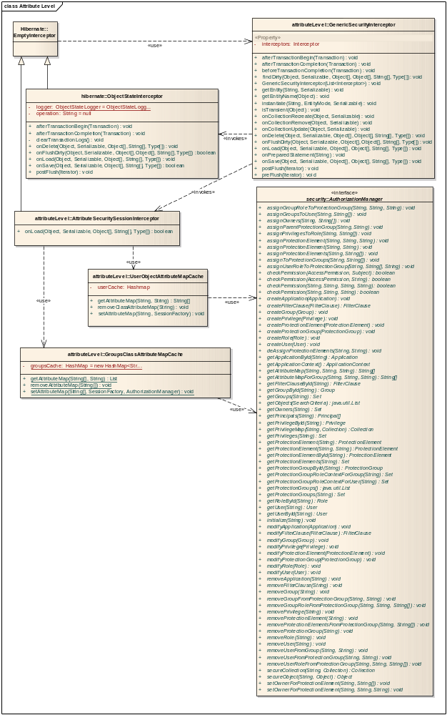

Source Code sample
public class GenericSecurityInterceptor extends EmptyInterceptor{
private List<Interceptor> interceptors;

public GenericSecurityInterceptor(List<Interceptor> interceptors){
this.interceptors = interceptors;
}

public void onDelete(Object entity, Serializable id, Object[] state, String[] propertyNames, Type[] types){

while(null!=interceptors && !interceptors.isEmpty()){
Iterator it = interceptors.iterator();
while(it.hasNext()){
Interceptor interceptor = (Interceptor) it.next();
interceptor.onDelete(entity, id, state, propertyNames,types);
}
}
}
. . . .
}

Provisioning Changes
There are no changes required to the existing UPT Tool for provisioning of the attribute level security integration with CLM.

Runtime Integration with SDK / Non SDK Systems – User
The following sequence diagram shows how a client system (SDK / Non SDK) would integrate the attribute level security.

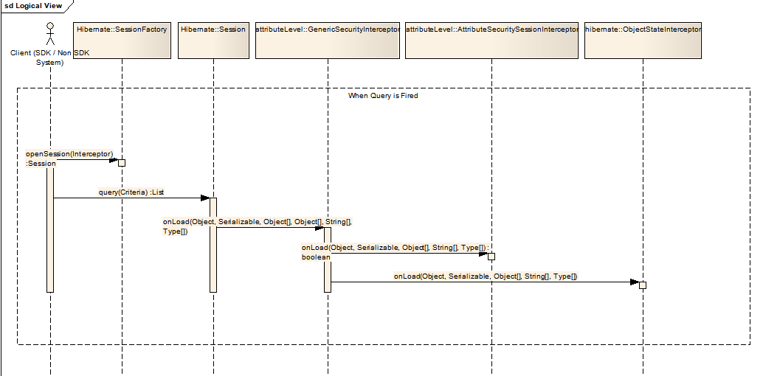

Database Changes
There are no database changes required to the CSM Authorization Schema
Unit Testing

JUnit Test Cases
This solution requires integration with a end user application. Also the testing of these is dependant on client applications model as well as data. Test Cases will be created to test Attribute Level security with CLM enabled and then disabled. Generated Log messages will be verified for validity.

Test Case Scenarios
The test case scenarios will be developed in conjunction with the QA Team. Based on the initial design the overall test scenarios are as mentioned below. Note that based on data each of these scenarios can have multiple test cases

  - Testing Attribute Level Security with CLM enabled
  - Testing Attribute Level Security with CLM disabled

Configuration/Deployment Considerations

Property/Configuration Files
  - The current configuration step for configuring the CSM Authorization APIs would be sufficient to support both Instance Level as well as Attribute Level Security.
  - Incase of SDK, three new properties will be added to the deployment configuration, allowing the end users to configure whether they want to enable Instance Level and Attribute Level security or not. Also to indicate whether the User Level or Group Level Security is desired.

Deployment Considerations
- All provisioning components will be packaged as part of CSM UPT. There is no special deployment requirement for either Instance Level or Attribute Level with respect to the UPT.
- All runtime components will be packaged as part of CSM APIs. Again there is no special deployment requirement for either Instance Level or Attribute Level with respect to the CSM APIs.

